Applications of group theory
Applications of group theory abound. Almost all structures in abstract algebra are special cases of groups. Rings, for example, can be viewed as abelian groups (corresponding to addition) together with a second operation (corresponding to multiplication). Therefore group theoretic arguments underlie large parts of the theory of those entities.
Galois theory uses groups to describe the symmetries of the roots of a polynomial (or more precisely the automorphisms of the algebras generated by these roots). The fundamental theorem of Galois theory provides a link between algebraic field extensions and group theory. It gives an effective criterion for the solvability of polynomial equations in terms of the solvability of the corresponding Galois group. For example, S₅, the symmetric group in 5 elements, is not solvable which implies that the general quintic equation cannot be solved by radicals in the way equations of lower degree can. The theory, being one of the historical roots of group theory, is still fruitfully applied to yield new results in areas such as class field theory.
Algebraic topology is another domain which prominently associates groups to the objects the theory is interested in. There, groups are used to describe certain invariants of topological spaces. They are called "invariants" because they are defined in such a way that they do not change if the space is subjected to some deformation. For example, the fundamental group "counts" how many paths in the space are essentially different. The Poincaré conjecture, proved in 2002/2003 by Grigori Perelman is a prominent application of this idea. The influence is not unidirectional, though. For example, algebraic topology makes use of Eilenberg–MacLane spaces which are spaces with prescribed homotopy groups. Similarly algebraic K-theory stakes in a crucial way on classifying spaces of groups. Finally, the name of the torsion subgroup of an infinite group shows the legacy of topology in group theory.
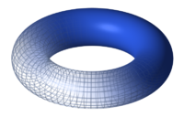
A torus. Its abelian group structure is induced from the map C → C/Z+τZ, where τ is a parameter.
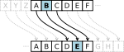
The cyclic group Z₂₆ underlies Caesar's cipher.
Algebraic geometry and cryptography likewise uses group theory in many ways. Abelian varieties have been introduced above. The presence of the group operation yields additional information which makes these varieties particularly accessible. They also often serve as a test for new conjectures.^{[6]} The one-dimensional case, namely elliptic curves is studied in particular detail. They are both theoretically and practically intriguing.^{[7]} Very large groups of prime order constructed in Elliptic-Curve Cryptography serve for public key cryptography. Cryptographical methods of this kind benefit from the flexibility of the geometric objects, hence their group structures, together with the complicated structure of these groups, which make the discrete logarithm very hard to calculate. One of the earliest encryption protocols, Caesar's cipher, may also be interpreted as a (very easy) group operation. In another direction, toric varieties are algebraic varieties acted on by a torus. Toroidal embeddings have recently led to advances in algebraic geometry, in particular resolution of singularities.^{[8]}
Algebraic number theory is a special case of group theory, thereby following the rules of the latter. For example, Euler's product formula
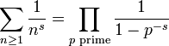
captures the fact that any integer decomposes in a unique way into primes. The failure of this statement for more general rings gives rise to class groups and regular primes, which feature in Kummer's treatment of Fermat's Last Theorem.
- The concept of the Lie group (named after mathematician Sophus Lie) is important in the study of differential equations and manifolds; they describe the symmetries of continuous geometric and analytical structures. Analysis on these and other groups is called harmonic analysis. Haar measures, that is integrals invariant under the translation in a Lie group, are used for pattern recognition and other image processing techniques.^{[9]}
- In combinatorics, the notion of permutation group and the concept of group action are often used to simplify the counting of a set of objects; see in particular Burnside's lemma.
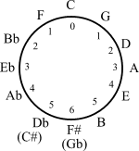
The circle of fifths may be endowed with a cyclic group structure
- The presence of the 12-periodicity in the circle of fifths yields applications of elementary group theory in musical set theory.
- In physics, groups are important because they describe the symmetries which the laws of physics seem to obey. According to Noether's theorem, every symmetry of a physical system corresponds to a conservation law of the system. Physicists are very interested in group representations, especially of Lie groups, since these representations often point the way to the "possible" physical theories. Examples of the use of groups in physics include the Standard Model, gauge theory, the Lorentz group, and the Poincaré group.
- In chemistry and materials science, groups are used to classify crystal structures, regular polyhedra, and the symmetries of molecules. The assigned point groups can then be used to determine physical properties (such as polarity and chirality), spectroscopic properties (particularly useful for Raman spectroscopy and infrared spectroscopy), and to construct molecular orbitals.

[edit] See also
- Group (mathematics)
- Glossary of group theory
- List of group theory topics

[edit] Notes
- ^ This process of imposing extra structure has been formalized through the notion of a group object in a suitable category. Thus Lie groups are group objects in the category of differentiable manifolds and affine algebraic groups are group objects in the category of affine algebraic varieties.
- ^ Schupp & Lyndon 2001
- ^ La Harpe 2000
- ^ Such as group cohomology or equivariant K-theory.
- ^ In particular, if the representation is faithful.
- ^ For example the Hodge conjecture (in certain cases).
- ^ See the Birch-Swinnerton-Dyer conjecture, one of the millennium problems
- ^ Abramovich, Dan; Karu, Kalle; Matsuki, Kenji; Wlodarczyk, Jaroslaw (2002), "Torification and factorization of birational maps", Journal of the American Mathematical Society 15 (3): 531–572, doi:10.1090/S0894-0347-02-00396-X, MR1896232
- ^ Lenz, Reiner (1990), Group theoretical methods in image processing, Lecture Notes in Computer Science, 413, Berlin, New York: Springer-Verlag, doi:10.1007/3-540-52290-5, ISBN 978-0-387-52290-6, http://webstaff.itn.liu.se/~reile/LNCS413/index.htm

[edit] References
- Borel, Armand (1991), Linear algebraic groups, Graduate Texts in Mathematics, 126 (2nd ed.), Berlin, New York: Springer-Verlag, ISBN 978-0-387-97370-8, MR1102012
- Carter, Nathan C. (2009), Visual group theory, Classroom Resource Materials Series, Mathematical Association of America, ISBN 978-0-88385-757-1, MR2504193, http://web.bentley.edu/empl/c/ncarter/vgt/
- Cannon, John J. (1969), "Computers in group theory: A survey", Communications of the Association for Computing Machinery 12: 3–12, doi:10.1145/362835.362837, MR0290613
- Frucht, R. (1939), "Herstellung von Graphen mit vorgegebener abstrakter Gruppe", Compositio Mathematica 6: 239–50, ISSN 0010-437X, http://www.numdam.org/numdam-bin/fitem?id=CM_1939__6__239_0
- Golubitsky, Martin; Stewart, Ian (2006), "Nonlinear dynamics of networks: the groupoid formalism", Bull. Amer. Math. Soc. (N.S.) 43 (03): 305–364, doi:10.1090/S0273-0979-06-01108-6, MR2223010 Shows the advantage of generalising from group to groupoid.
- Judson, Thomas W. (1997), Abstract Algebra: Theory and Applications, http://abstract.ups.edu An introductory undergraduate text in the spirit of texts by Gallian or Herstein, covering groups, rings, integral domains, fields and Galois theory. Free downloadable PDF with open-source GFDL license.
- Kleiner, Israel (1986), "The evolution of group theory: a brief survey", Mathematics Magazine 59 (4): 195–215, doi:10.2307/2690312, ISSN 0025-570X, JSTOR 2690312, MR863090
- La Harpe, Pierre de (2000), Topics in geometric group theory, University of Chicago Press, ISBN 978-0-226-31721-2
- Livio, M. (2005), The Equation That Couldn't Be Solved: How Mathematical Genius Discovered the Language of Symmetry, Simon & Schuster, ISBN 0-7432-5820-7 Conveys the practical value of group theory by explaining how it points to symmetries in physics and other sciences.
- Mumford, David (1970), Abelian varieties, Oxford University Press, ISBN 978-0-19-560528-0, OCLC 138290
- Ronan M., 2006. Symmetry and the Monster. Oxford University Press. ISBN 0-19-280722-6. For lay readers. Describes the quest to find the basic building blocks for finite groups.
- Rotman, Joseph (1994), An introduction to the theory of groups, New York: Springer-Verlag, ISBN 0-387-94285-8 A standard contemporary reference.
- Schupp, Paul E.; Lyndon, Roger C. (2001), Combinatorial group theory, Berlin, New York: Springer-Verlag, ISBN 978-3-540-41158-1
- Scott, W. R. (1987) [1964], Group Theory, New York: Dover, ISBN 0-486-65377-3 Inexpensive and fairly readable, but somewhat dated in emphasis, style, and notation.
- Shatz, Stephen S. (1972), Profinite groups, arithmetic, and geometry, Princeton University Press, ISBN 978-0-691-08017-8, MR0347778
- Weibel, Charles A. (1994), An introduction to homological algebra, Cambridge Studies in Advanced Mathematics, 38, Cambridge University Press, ISBN 978-0-521-55987-4, OCLC 36131259, MR1269324

Symmetry and Group Theory

Cataloging the symmetry of molecules is very useful.

Group Theory is a mathematical method by which aspects of a molecules symmetry can be determined.

The symmetry of a molecule reveals information about its properties (i.e., structure, spectra, polarity, chirality, etc…)

Clearly, the symmetry of the linear molecule A-B-A is different from A-A-B.

In A-B-A the A-B bonds are equivalent, but in A-A-B they are not.

However, important aspects of the symmetry of H₂O and CF₂Cl₂ are the same. This is not obvious without Group Theory.

Symmetry Operations/Elements

A molecule or object is said to possess a particular operation if that operation when applied leaves the molecule unchanged.

Each operation is performed relative to a point, line, or plane - called a symmetry element.

There are 5 kinds of operations

1. Identity

2. n-Fold Rotations

3. Reflection

4. Inversion

5. Improper n-Fold Rotation

1. Identity is indicated as E

does nothing, has no effect

all molecules/objects possess the identity operation, i.e., posses E.

E has the same importance as the number 1 does in multiplication (E is needed in order to define inverses).

2. n-Fold Rotations: C_{n}, where n is an integer

rotation by 360°/n about a particular axis defined as the n-fold rotation axis.

C₂ = 180° rotation, C₃ = 120° rotation, C₄ = 90° rotation, C₅ = 72° rotation, C₆ = 60° rotation, etc.

Rotation of H₂O about the axis shown by 180° (C₂) gives the same molecule back.

Therefore H₂O possess the C₂ symmetry element.
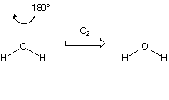

However, rotation by 90° about the same axis does not give back the identical molecule

Therefore H₂O does NOT possess a C₄ symmetry axis.
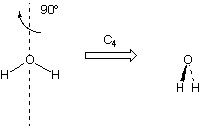

BF₃ posses a C₃ rotation axis of symmetry.

(Both directions of rotation must be considered)
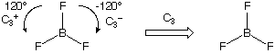
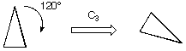

This triangle does not posses a C₃ rotation axis of symmetry.
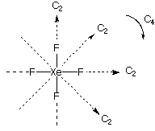

XeF₄ is square planar.

It has four DIFFERENT C₂ axes

It also has a C₄ axis coming out of the page called the principle axis because it has the largest n.

By convention, the principle axis is in the z-direction

3. Reflection: σ (the symmetry element is called a mirror plane or plane of symmetry)

If reflection about a mirror plane gives the same molecule/object back than there is a plane of symmetry (σ).

If plane contains the principle rotation axis (i.e., parallel), it is a vertical plane (σ_{v})

If plane is perpendicular to the principle rotation axis, it is a horizontal plane (σ_{h})

If plane is parallel to the principle rotation axis, but bisects angle between 2 C₂ axes, it is a diagonal plane (σ_{d})

H₂O posses 2 σ_{v} mirror planes of symmetry because they are both parallel to the principle rotation axis (C₂)
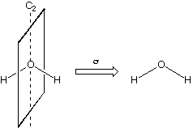
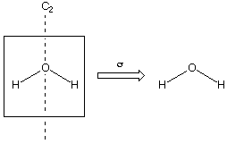

XeF₄ has two planes of symmetry parallel to the principle rotation axis: σ_{v}

XeF₄ has two planes of symmetry parallel to the principle rotation axis and bisecting the angle between 2 C₂ axes : σ_{d}

XeF₄ has one plane of symmetry perpendicular to the principle rotation axis: σ_{h}
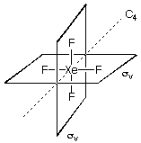 | 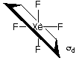 | 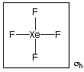

4. Inversion: i (the element that corresponds to this operation is a center of symmetry or inversion center)

The operation is to move every atom in the molecule in a straight line through the inversion center to the opposite side of the molecule.
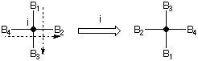

Therefore XeF₄ posses an inversion center at the Xe atom.

5. Improper Rotations: S_{n}

n-fold rotation followed by reflection through mirror plane perpendicular to rotation axis

Note: n is always 3 or larger because S₁ = σ and S₂ = i.
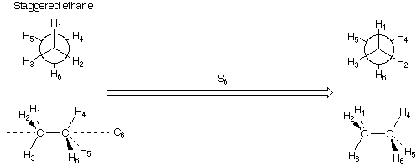
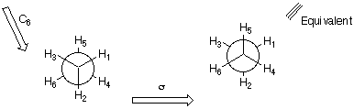
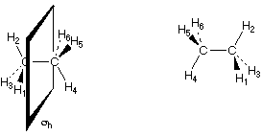
These are different, therefore this molecule
does not posses a C₃ symmetry axis.

This molecule posses the following symmetry elements: C₃, 3 σ_{d}, i, 3 ⊥ C₂, S₆. There is no C₃ or σ_{h}.

Eclipsed ethane posses the following symmetry elements: C₃, 3 σ_{v}, 3 ⊥ C₂, S₃, σ_{h}. There is no S₆ or i.
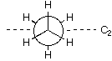
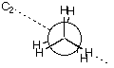

Compiling all the symmetry elements for staggered ethane yields a Symmetry Group called D_{3d}.

Compiling all the symmetry elements for eclipsed ethane yields a Symmetry Group called D_{3h}.

Symmetry group designations will be discussed in detail shortly

To be a group several conditions must be met:

1. Any result of two or more operations must produce the same result as application of one operation within the group.

i.e., the group multiplication table must be closed

Consider H₂O which has E, C₂ and 2 σ_{v}'s.
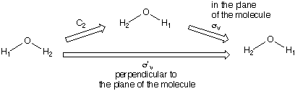

i.e.,

of course

etc…

The group multiplication table obtained is therefore:
 | E | C₂ | σ_{v} | σ'_{v}
E | E | C₂ | σ_{v} | σ'_{v}
C₂ | C₂ | E | σ'_{v} | σ_{v}
σ_{v} | σ_{v} | σ'_{v} | E | C₂
σ'_{v} | σ'_{v} | σ_{v} | C₂ | E

Note: the table is closed, i.e., the results of two operations is an operation in the group.

2. Must have an identity ()

3. All elements must have an inverse

i.e., for a given operation () there must exist an operation () such that

Classification of the Symmetry of Molecules

Certain symmetry operations can be present simultaneously, while others cannot.

There are certain combinations of symmetry operations which can occur together.

Symmetry Groups combine symmetry operations that can occur together.

Symmetry groups contain elements and there mathematical operations.

For example, one of the symmetry element of H₂O is a C₂-axis. The corresponding operation is rotation of the molecule by 180° about an axis.

Point Groups

Low Symmetry Groups
C₁: only E
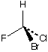
C_{s}: E and σ only
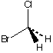
C_{i}: E and i only
• 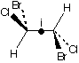

C_{n}, C_{nv}, C_{nh} Groups
C_{n}: E and C_{n} only
C_{2:}
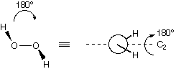
C_{3:}
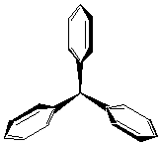

C_{nv}: E and C_{n} and n σ_{v}'s
C_{2v}: E, C₂, 2 σ_{v} H₂O
C_{3v}: E, C₃, 3 σ_{v} NH₃
C _{v}: E, C , σ_{v} HF, HCN

C_{nh}: E and C_{n} and σ_{h} (and others as well)
C_{2h}: E, C₂, σ_{h}, i
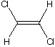

D_{n}, D_{nv}, D_{nh} Groups
D_{n}: E, C_{n}, n C₂ axes ⊥ to C_{n}
D₃: E, C₃, 3 ⊥ C₂
[Co(en)₃]³⁺
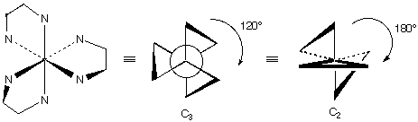

D_{nh}: E, C_{n}, n C₂ axes ⊥ to C_{n}, σ_{h}
D_{3h}: E, C₃, 3 ⊥ C₂, σ_{h}
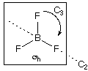
• D_{3h}: E, C₃, 3 ⊥ C₂, σ_{h}
eclipsed ethane
D_{6h}: E, C₆, 6 ⊥ C₂, σ_{h}
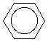
• D _{h}: E, C , ⊥ C₂, σ_{h}
H₂

D_{nd}: E, C_{n}, n C₂ axes ⊥ to C_{n},
• D_{3d}: E, C₃, 3 ⊥ C₂, 3 σ_{d}
staggered ethane

S_{n} Group
S_{2n}: E, C_{n}, S_{2n} (no mirror planes)
S₄, S₆, S₈, etc. (Note: never S₃, S₅, etc.)
S₄: E, C₂, S₄
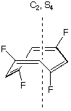

High Symmetry Cubic Groups, T_{d}, O_{h}, I_{h}
T_{d}: E, 8 C₃, 3 C₂, 6 S₄, 6 σ_{d}
Tetrahedral structures
No need to identify all the symmetry elements - simply recognize T_{d} shape.
methane, CH₄
O_{h}: E, 8 C₃, 6 C₂, 6 C₄, i, 6 S₄, 8 S₆, 3 σ_{h}, 6 σ_{d}
Octahedral structures
No need to identify all the symmetry elements - simply recognize O_{h} shape.
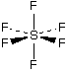
I_{h}: E, 12 C₅, 20 C₃, 15 C₂, i, 12 S₁₀, 20 S₆, 15 σ
Icosahedron
Other rare high symmetry groups are T, T_{h}, O, and I

